**Prediction of Heart Failure using The IBM AUTO-AI Service**

**→ Introduction:**

* **Overview:**

Heart disease has been the leading cause of death for decades all across the world so it’s no surprise that heart failure rates, which is a specific type of heart disease characterized by when the heart is too weak to pump blood throughout the body, are on the rise. In fact, the number of adults with heart failure is expected to increase by 46 percent by 2030. That means eight million people will have heart failure by then; and about half of people who have heart failure die within five years of diagnosis.

Hence, creating a predictive model and creating awareness about this health condition by encouraging people to take early diagnosis by providing our prediction is the need of the hour!

* **Purpose:**

Machine learning is an emerging subdivision of artificial intelligence. Its primary focus is to design systems, allow them to learn and make predictions based on the experience.The aim / purpose of this project is to predict whether or not a patient will develop heart failure. This project is done on supervised machine learning classification technique Random Forest Classifier on the dataset, using the popular IBM - AUTO AI SERVICE.

**→ Literature Survey:**

* **Existing Problem:**

Cardiovascular diseases (CVDs) are the number 1 cause of death globally, taking an estimated 17.9 million lives each year, which accounts for 31% of all deaths worldwide.Heart failure is a common event caused by CVDs and this dataset contains 9 features that can be used to predict mortality by heart failure. Heart failure signs and symptoms may include: Shortness of breath (dyspnea) when you exert yourself or when you lie down. Fatigue and weakness. Swelling (edema) in your legs, ankles and feet. Also, it is so sudden that one just cannot be certain of its occurrence.

* **Proposed Solution:**

In order to predict a possible chance of heart failure in the near future, we build an AUTO - AI service that takes our various health determining parameters specifically contributing to the research of heart failure, and predict the possibility and we integrate our AUTO AI Experiment with one of the versatile UI: NODE - RED Application in order to showcase our predicted result of heart failure chances to the user in an efficient manner.

→ **Theoretical Analysis:**

**Block Diagram:**

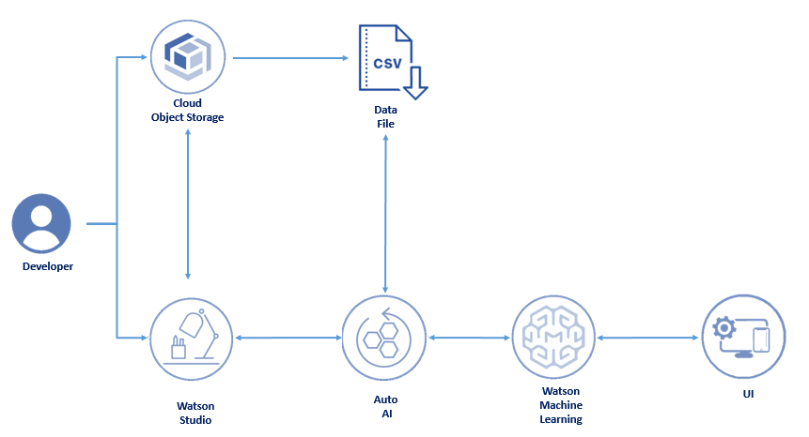

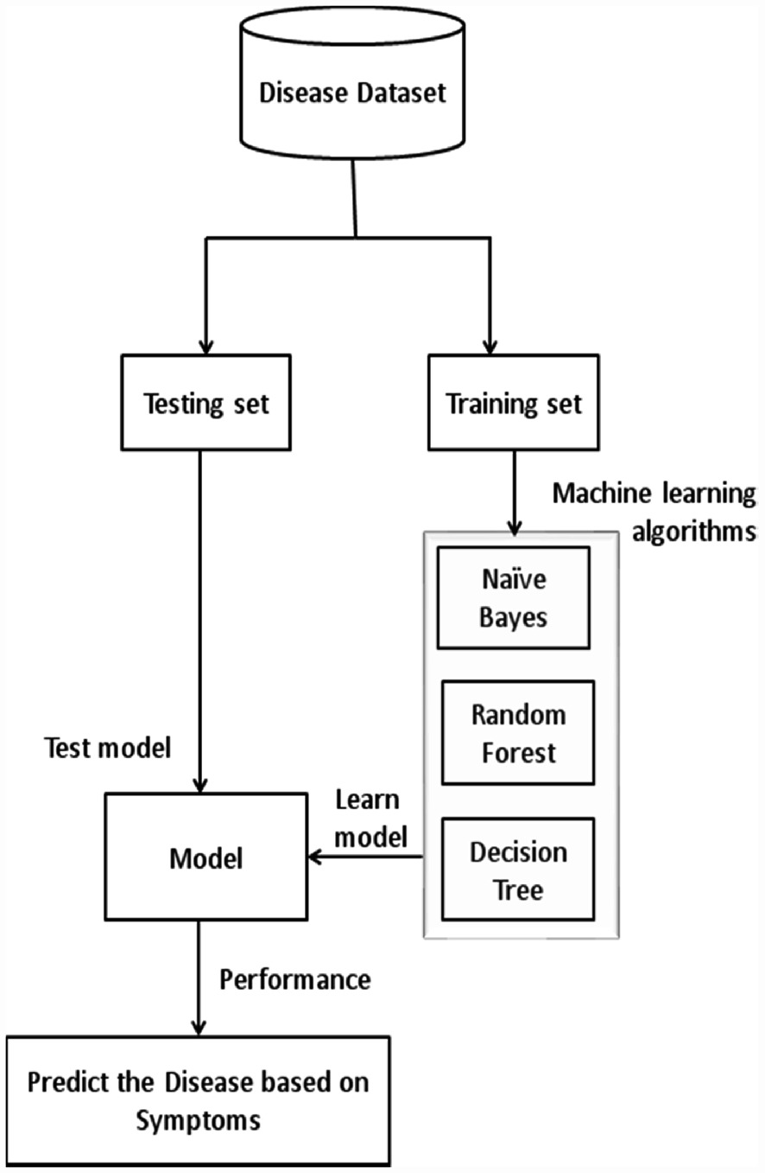

→ **Hardware / Software Designing:**

**Hardware:**

* OS - Windows 7, 10.
* RAM - x32, x64.
* Processor - CORE i5, i7 +

**Software:**

* IBM Cloud Software
* IBM Watson Studio
* IBM Watson Machine Learning
* Node-RED
* IBM Cloud Object Storage

→ **Experimental Investigation:**

In this experiment, we first log into our IBM cloud accounts and create a Watson Studio service and a Node - Red app under the Cloud foundry account. Then, we create a project in our Watson Studio and add our AUTO-AI service to the project by naming it and setting up the Cloud Storage. Then we create a Machine Learning service and associate it with our AUTO-AI service. We then upload our dataset and select the result parameter ( which is HEARTFAILURE in our case ) and then click on “Run Experiment”.

The AUTO-AI service will then perform the experiment and create a set of pipelines for deciding the ML model. Then according to the Optimising parameter we have chosen to select our model ( which in our case we took Accuracy ), the best pipeline will be ranked on the top and we have to save that pipeline as our ML Model. Then we have to promote the model into the Deployment Space after creating one. After that we have to deploy our model and finally test it.

Now, for the NODE - RED UI integration with our IBM AUTO-AI experiment, we have to go to our NODE-RED Flow Editor and construct our flow.

We have to take a form node, and 3 drop-down nodes and set the values according to our dataset. Then we take the function nodes for each of the above created nodes respectively and assign the global variables to them.

We also create our API Key and then we connect a http - request node and set it to POST mode and set it such that we can get our access token using the API Key. Then we deploy a series or function - http - debug nodes and construct the flowin such a manner that we can grab our global variable values and set it to the locally created values. Then again we take the END - POINT URL from our IBM - Deployed Model Space and set it as the target URL in one of the http - request nodes in our NODE - RED flow.

We then copy the path of the result flow and give it as a payload argument so that the user gets a clarified output as to “Yes” or “No” for the possible Heart Failure Result. Then we deploy our flow and try entering values into the created UI window.

With everything properly done, we shall get our output and this is how the entire Prediction of Heart Failure using the IBM AUTO - AI Service works!!

→ **Flowchart:**

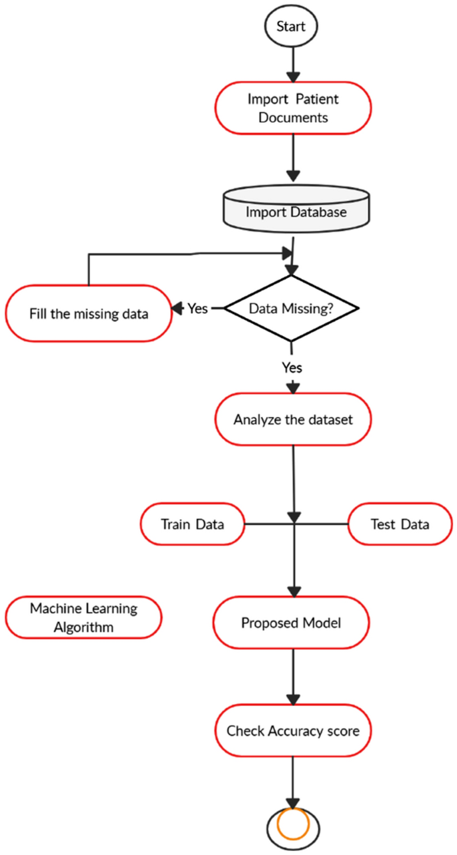

→ **Result:** After successfully performing the experiment and deploying the model into the created deployment space, we can view our result in the “Test” section of our IBM Cloud platform. Here, we will get the answer in the following format: Either “Y” ( indicating Yes ) or “N” ( indicating No ) in our IBM Cloud Platform along with the precision and probability.

Also after integrating with NODE - RED and successfully deploying our FLOW, we can enter the values from the User Interface and then we will be seeing our result as “Y” or “N” depending on the entered values.

Thus, in this manner we can predict the possibility of Heart Failure by our AUTO-AI Service integrated with NODE - RED platform and this project will hopefully reduce the risk of Heart Failure by encouraging people to go forward and take an early diagnosis by providing them the possible prediction and probability.

→ **Advantages & Disadvantages:**

* **Advantages:**
* The model is Efficient
* It is Accurate
* Proven effectiveness of predicting correct result about 88%
* Creation of an AUTO-AI service is really fast.
* Less time taken for execution of the prediction.
* **Disadvantages:**
* The accuracy of the AUTO - AI Service is not as high as what it would be in case of a manual model creation.
* Lack of data or parameters will not lead to an effective / successful prediction of Heart Failure.

→ **Applications:**

* Machine learning and artificial intelligence are generating significant attention in the scientific community and media. Such algorithms have great potential in medicine for personalizing and improving patient care, including in the diagnosis and management of heart failure. Many physicians are familiar with these terms and the excitement surrounding them, but many are unfamiliar with the basics of these algorithms and how they are applied to medicine. Within heart failure research, current applications of machine learning include creating new approaches to diagnosis, classifying patients into novel phenotypic groups, and improving prediction capabilities. In this paper, we provide an overview of machine learning targeted for the practicing clinician and evaluate current applications of machine learning in the diagnosis, classification, and prediction of heart failure.
* Using machine learning techniques, specially using the AUTO - AI Service the **heart disease** can be predicted. The medical data such as Blood pressure, hypertension, diabetes,cigarette smoked per day and so on is taken as input and then these features are modelled for **prediction**. This model can then be used to **predict** future medical data.

→ **Conclusion:**

Heart diseases when aggravated spiral way beyond control. Heart diseases are complicated and take away lots of lives every year.When the early symptoms of heart diseases are ignored, the patient might end up with drastic consequences in a short span of time. Sedentary lifestyle and excessive stress in today’s world have worsened the situation. If the disease is detected early then it can be kept under control. However, it is always advisable to exercise daily and discard unhealthy habits at the earliest. Tobacco consumption and unhealthy diets increase the chances of stroke and heart diseases. Eating at least 5 servings of fruits and vegetables a day is a good practice. For heart disease patients, it is advisable to restrict the intake of salt to one teaspoon per day. One of the major drawbacks of these works is that the main focus has been on the application of classification techniques for heart disease prediction, rather than studying various data cleaning and pruning techniques that prepare and make a dataset suitable for mining. It has been observed that a properly cleaned and pruned dataset provides much better accuracy than an unclean one with missing values. Selection of suitable techniques for data cleaning along with proper classification algorithms will lead to the development of prediction systems that give enhanced accuracy. In future an intelligent system may be developed that can lead to selection of proper treatment methods for a patient diagnosed with heart disease. A lot of work has been done already in making models that can predict whether a patient is likely to develop heart disease or not. There are several treatment methods for a patient once diagnosed with a particular form of heart disease. Data mining can be of very good help in deciding the line of treatment to be followed by extracting knowledge from such suitable databases.

→ **Future Scope:**

Machine Learning is used across many spheres around the world. The healthcare industry is no exception. Machine Learning can play an essential role in predicting presence/absence of Locomotor disorders, Heart diseases and more. Such information, if predicted well in advance, can provide important insights to doctors who can then adapt their diagnosis and treatment per patient basis.

The silver lining is that heart attacks are highly preventable and simple lifestyle modifications(such as reducing alcohol and tobacco use; eating healthily and exercising) coupled with early treatment greatly improves its prognosis. It is, however, difficult to identify high risk patients because of the multifactorial nature of several contributory risk factors such as diabetes, high blood pressure, high cholesterol, et cetera. This is where machine learning and data mining come to the rescue.

Doctors and scientists alike have turned to machine learning (ML) techniques to develop screening tools and this is because of their superiority in pattern recognition and classification as compared to other traditional statistical approaches.

→ **Bibliography:**

1.Tripoliti EE, Papadopoulos TG, Karanasiou GS, Naka KK, Fotiadis DI. Heart failure: diagnosis, severity estimation and prediction of adverse events through machine learning techniques. Comput Struct Biotechnol J. 2017; 15:26–47.

2. Noble, W. S. Support vector machine applications in computational biology. *Kernel Methods Comput. Biol.* **71**, 92 (2004).

3. Soni J, Ansari U, Sharma D and Soni S 2011 Predictive data mining for medical diagnosis: an overview of heart disease prediction *International Journal of Computer Applications* **17** 43-8

4. Chen A H, Huang S Y, Hong P S, Cheng C H and Lin E J HDPS: Heart disease prediction system *2011 Computing in Cardiology* (IEEE) 557-60

5. Shinde R, Arjun S, Patil P and Waghmare J 2015 An intelligent heart disease prediction system using k-means clustering and Naïve Bayes algorithm *International Journal of Computer Science and Information Technologies* **6** 637-9

→ **Appendix:**

1. **Source Code:** 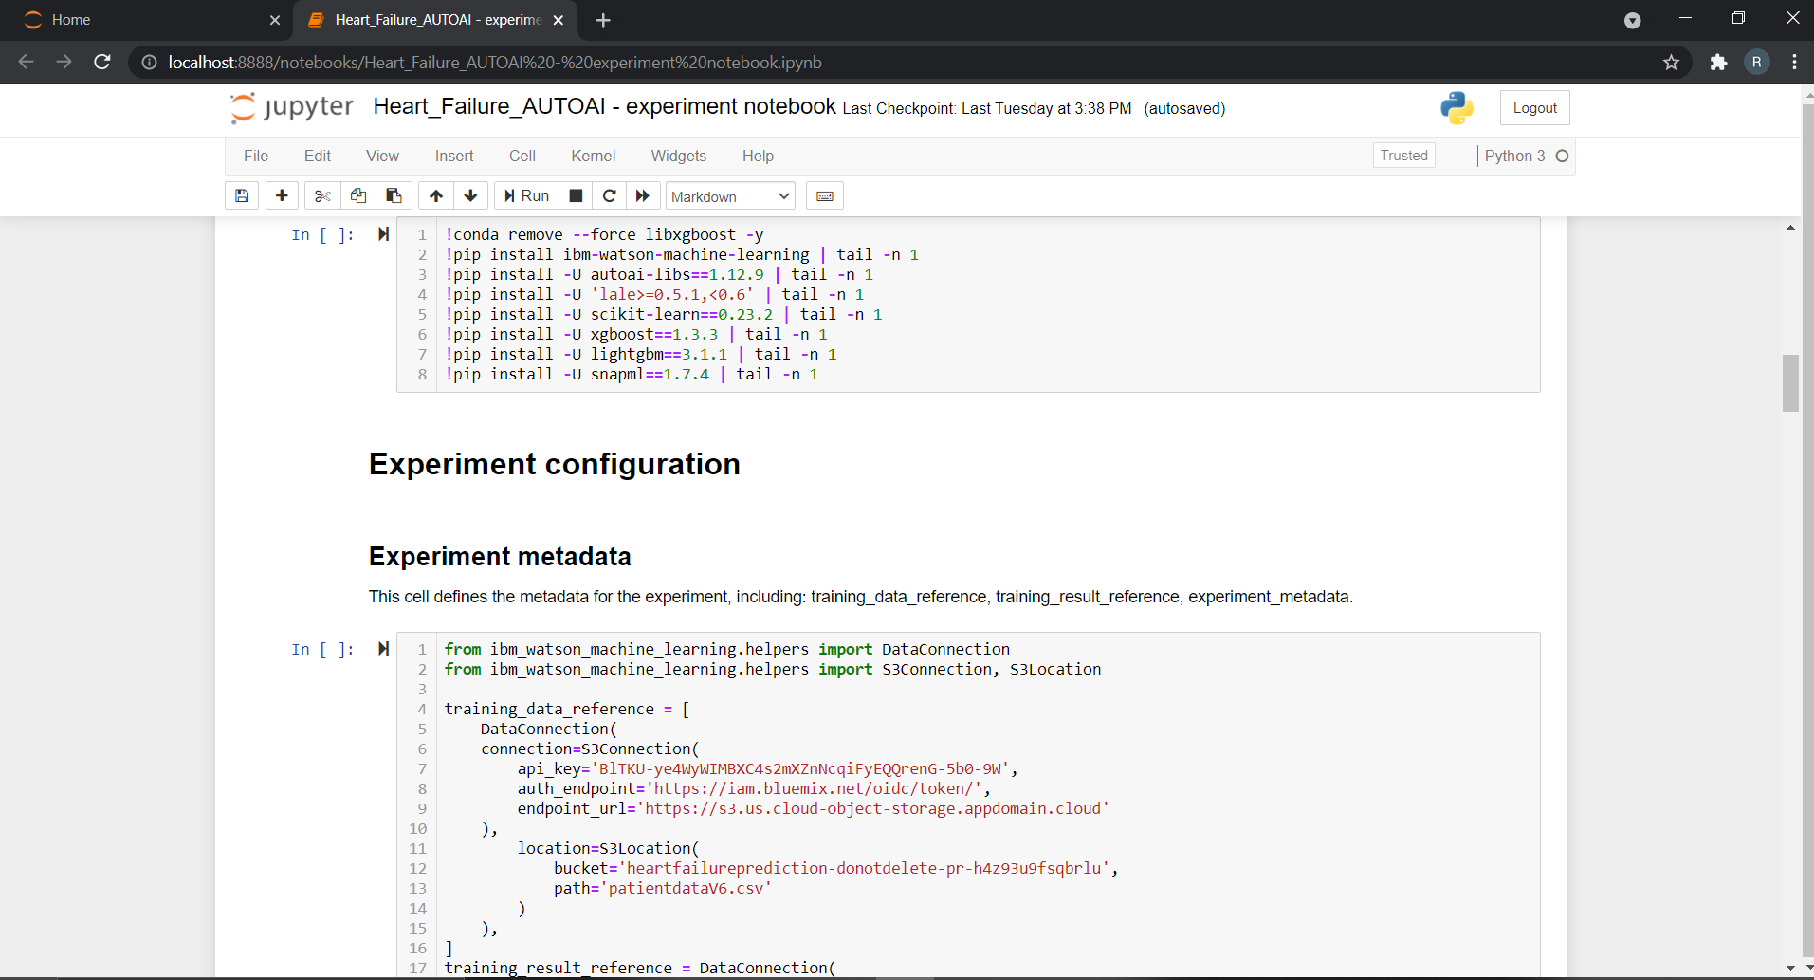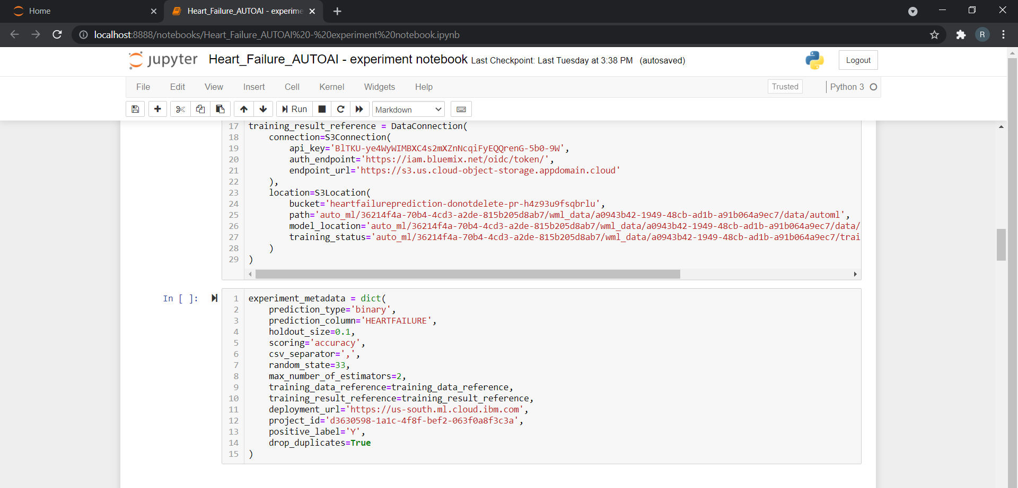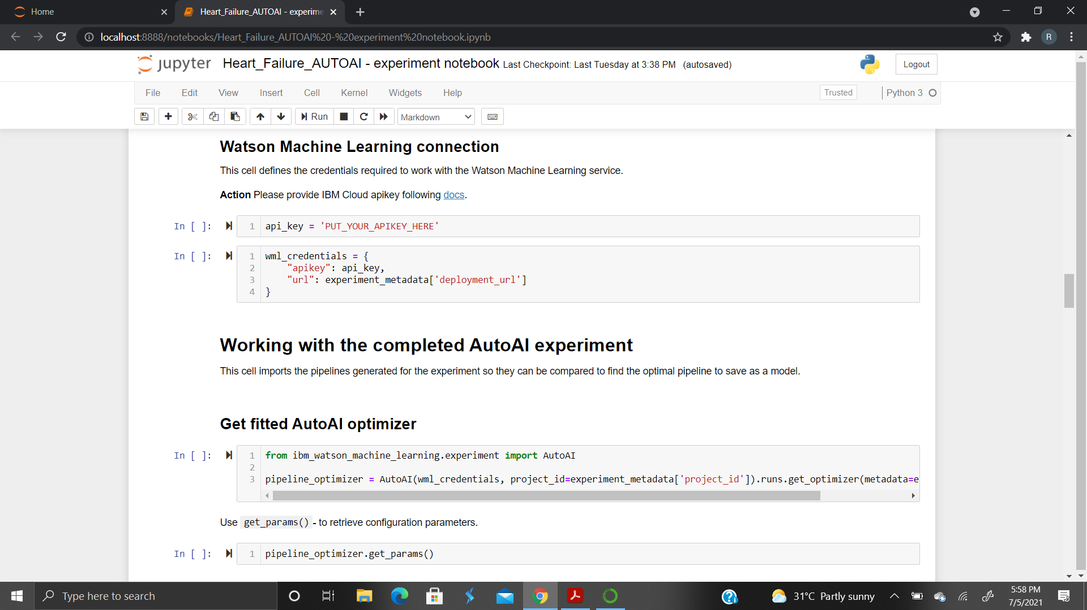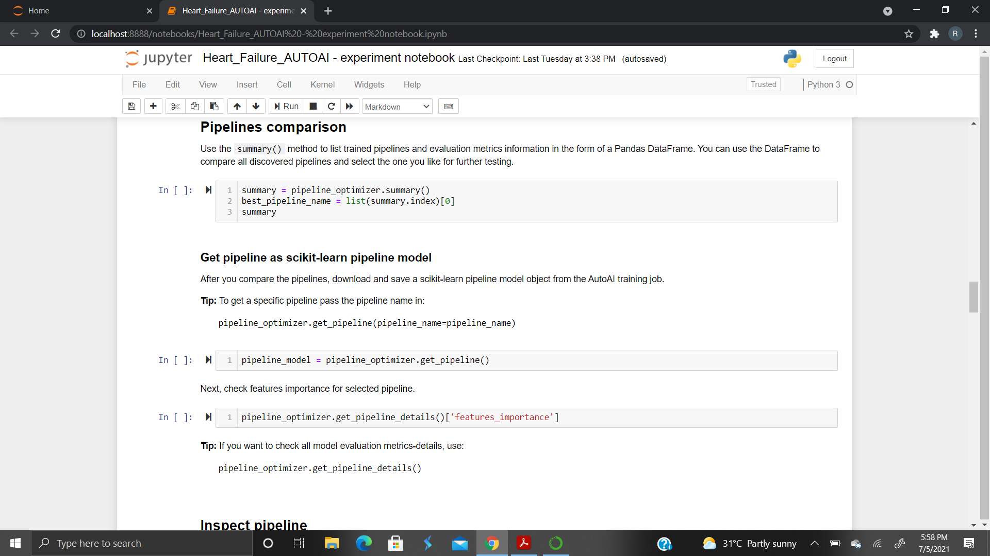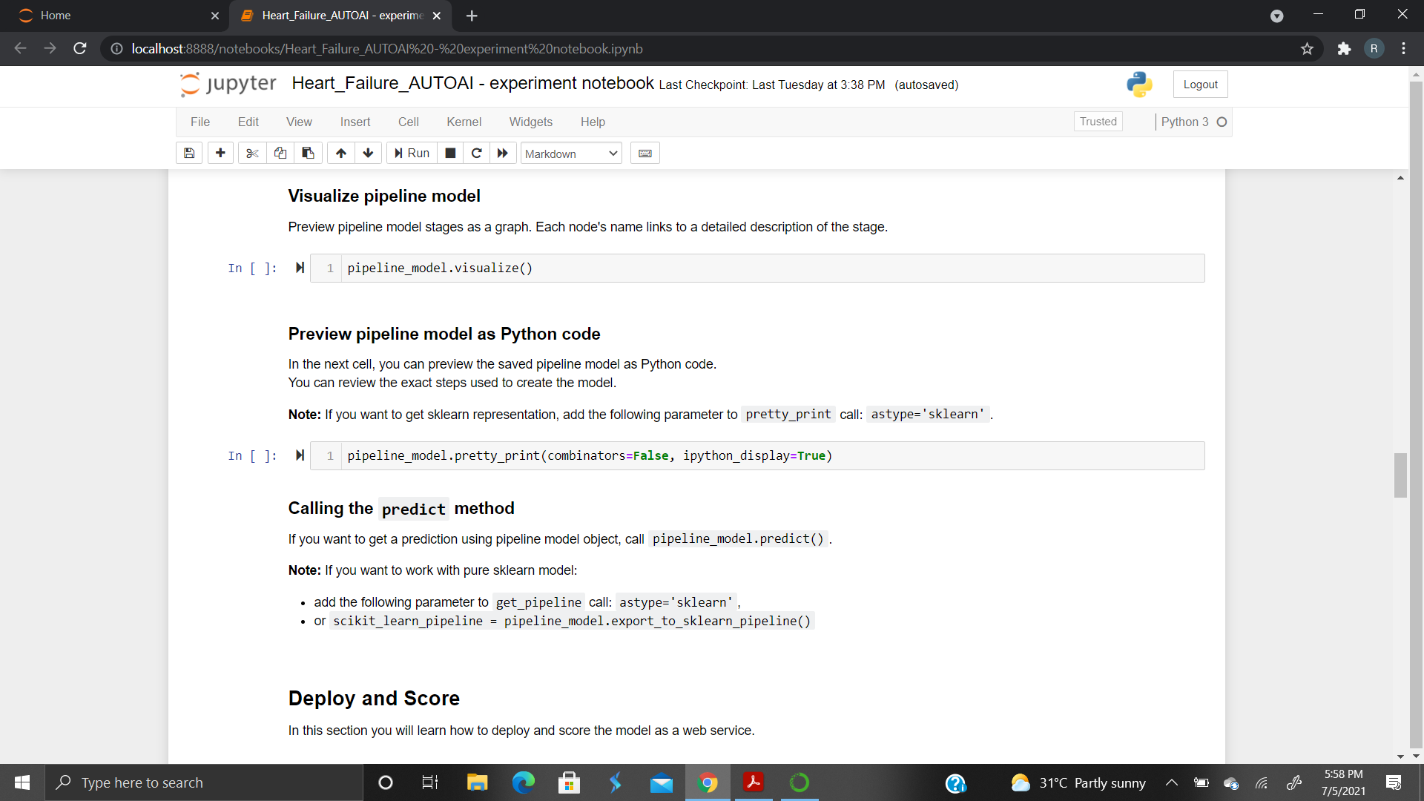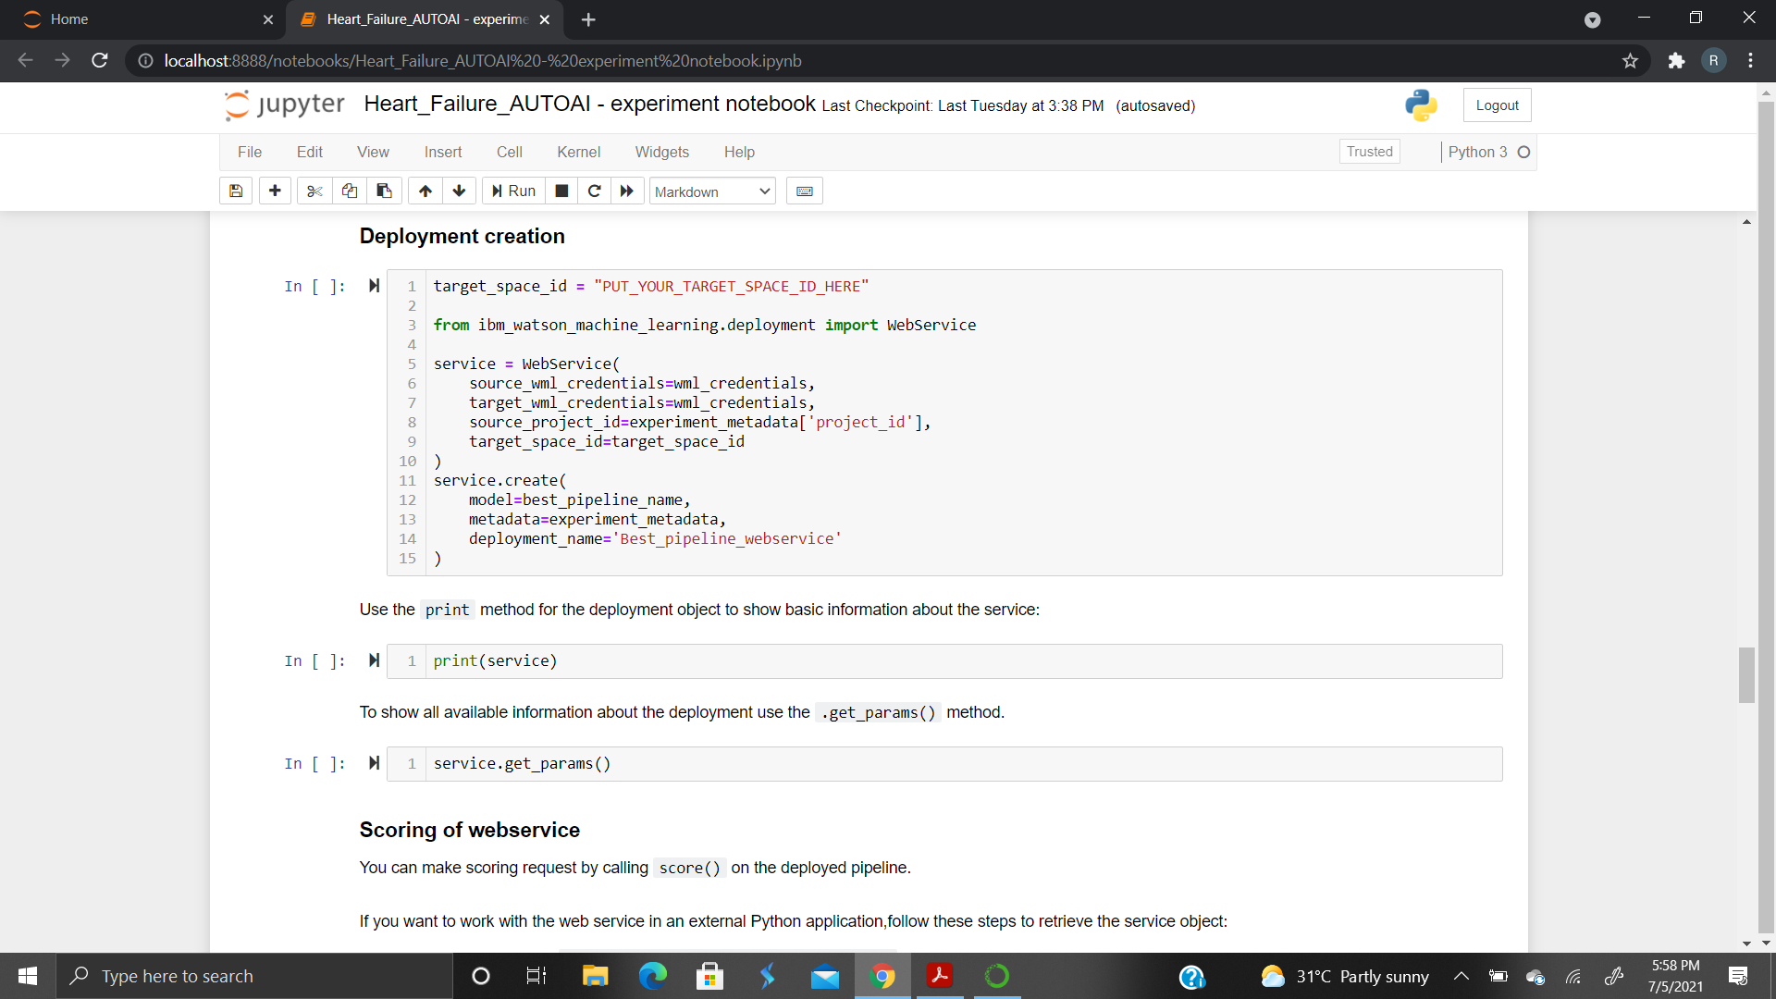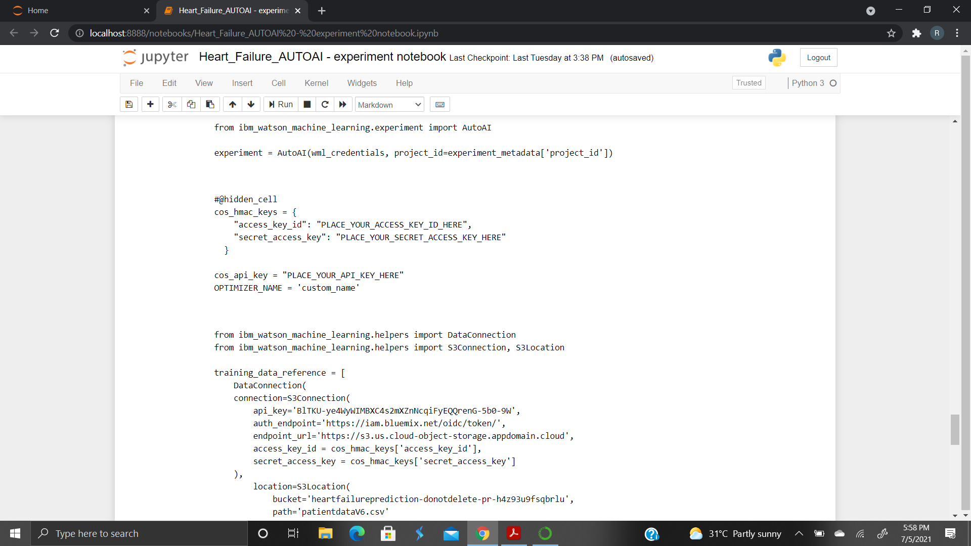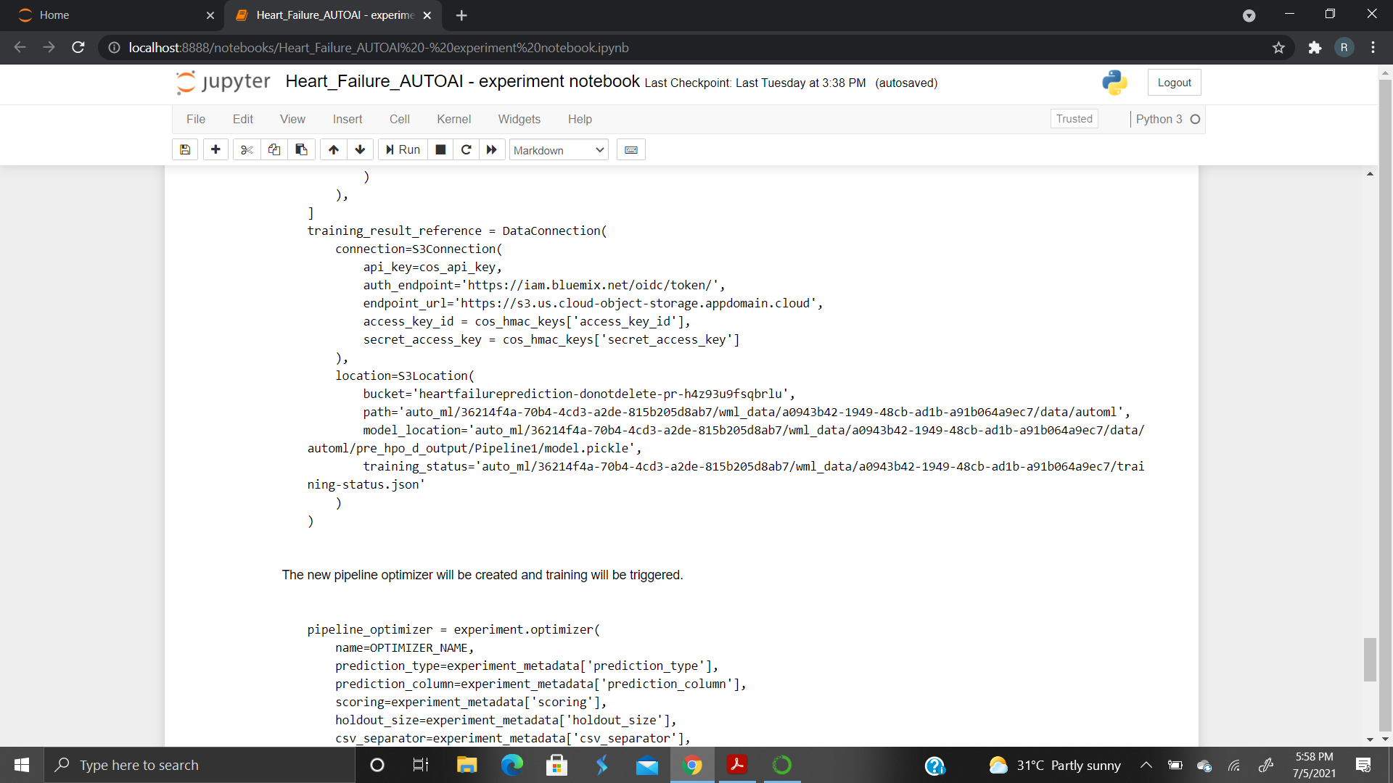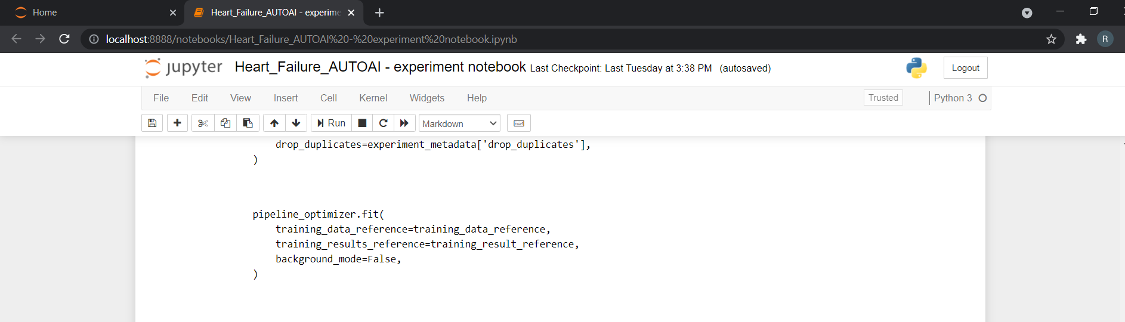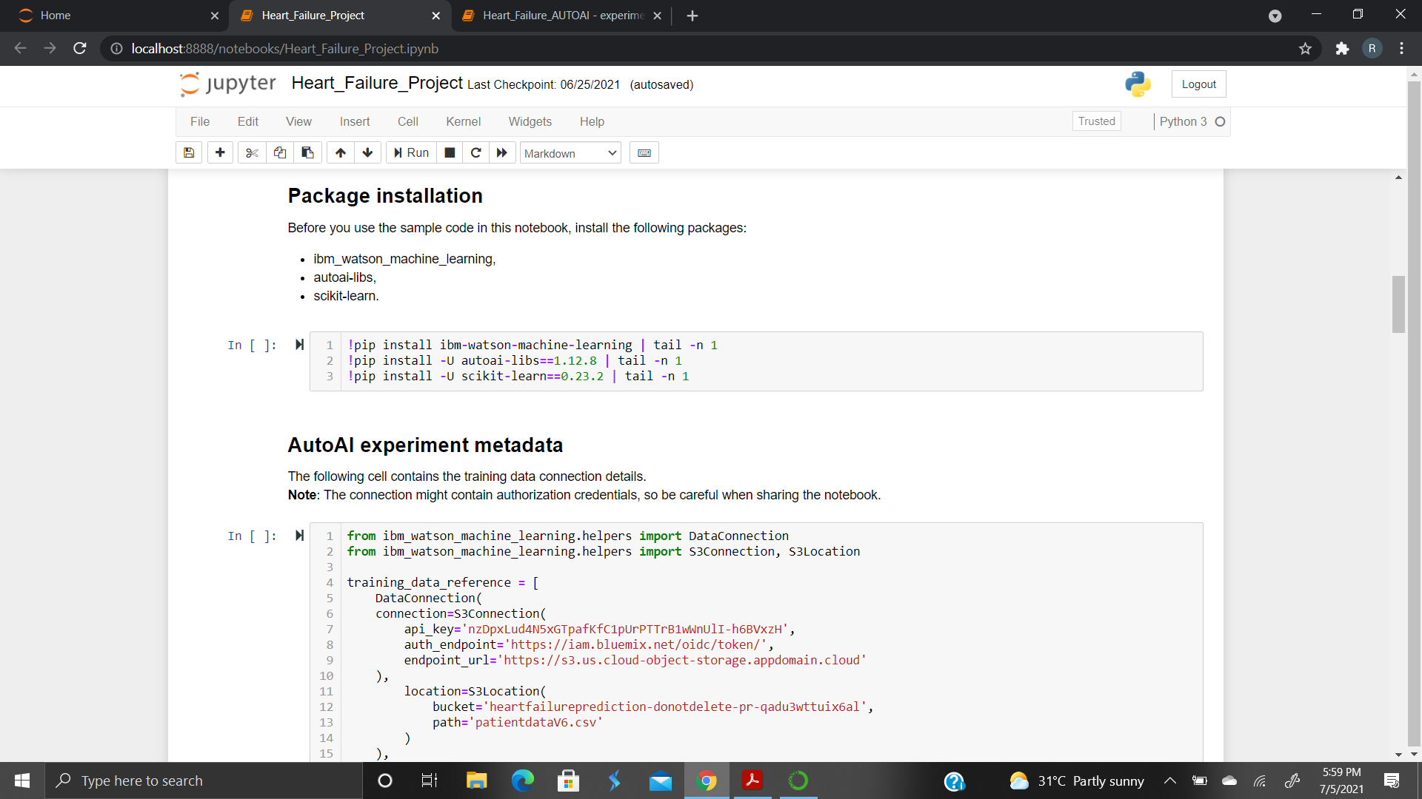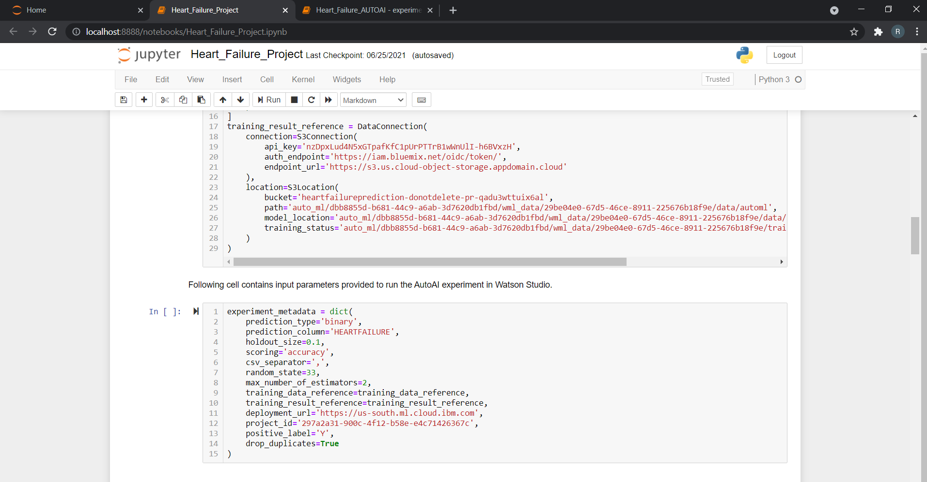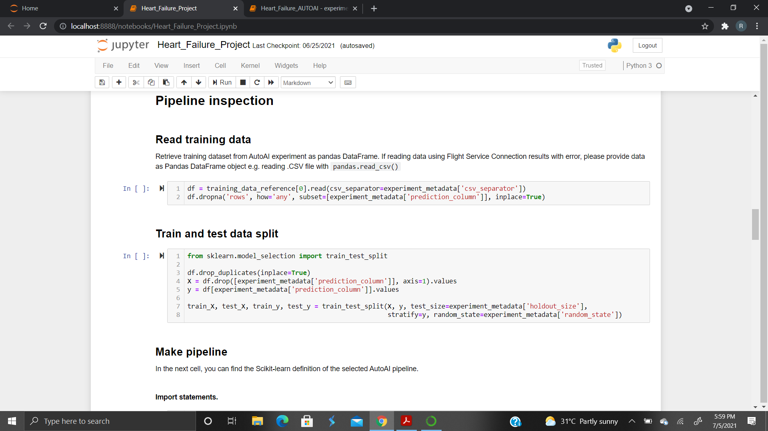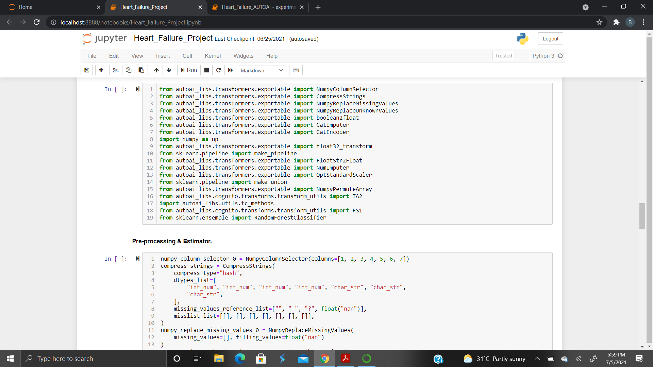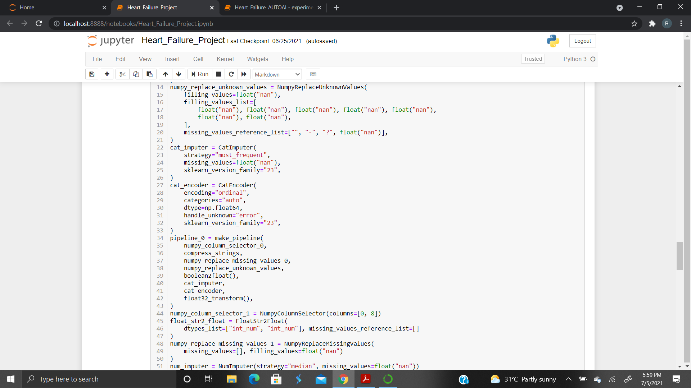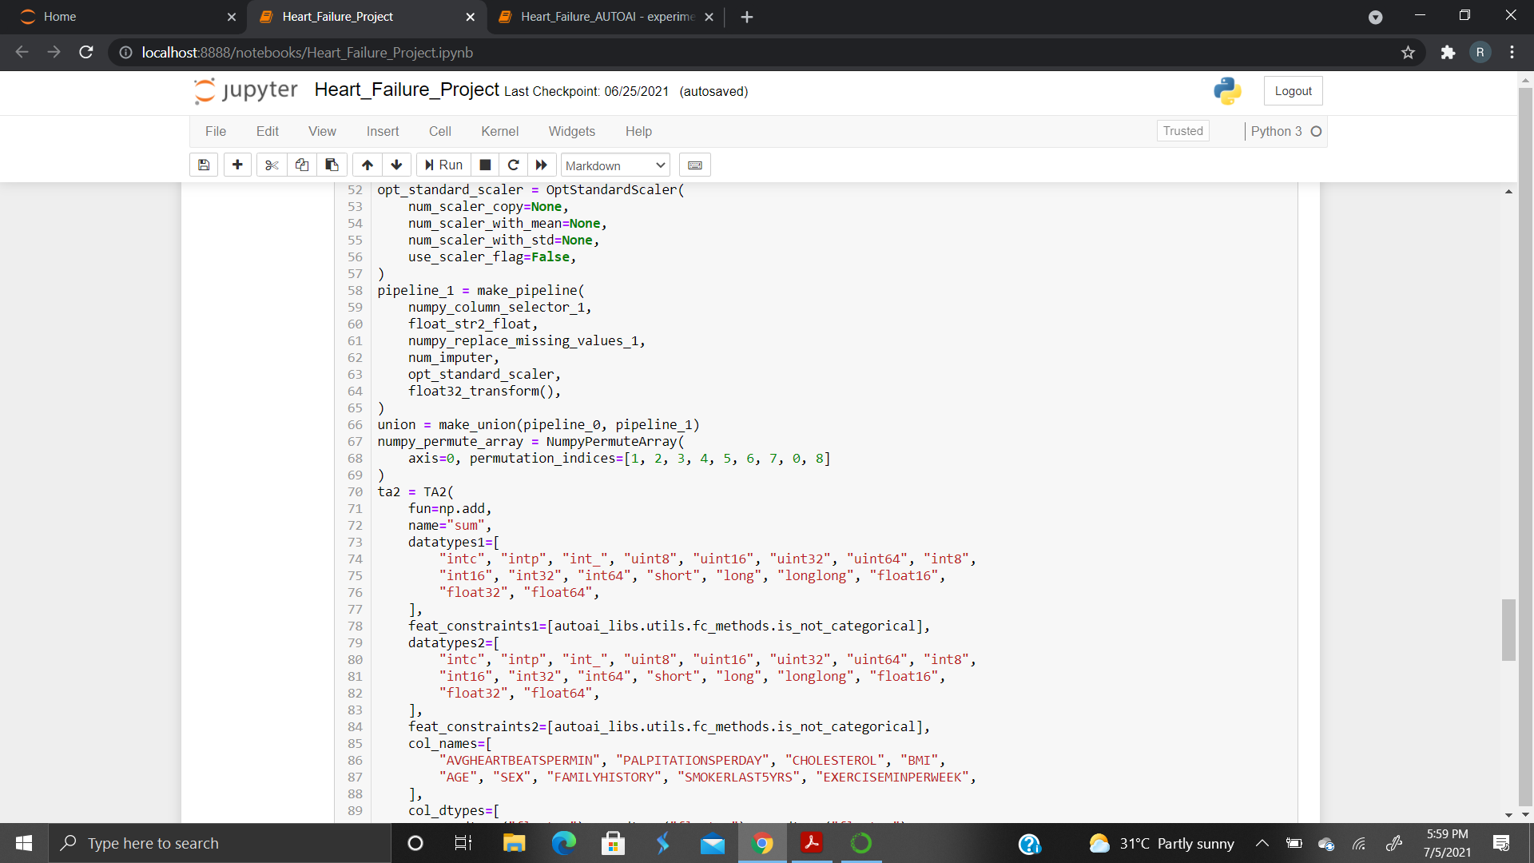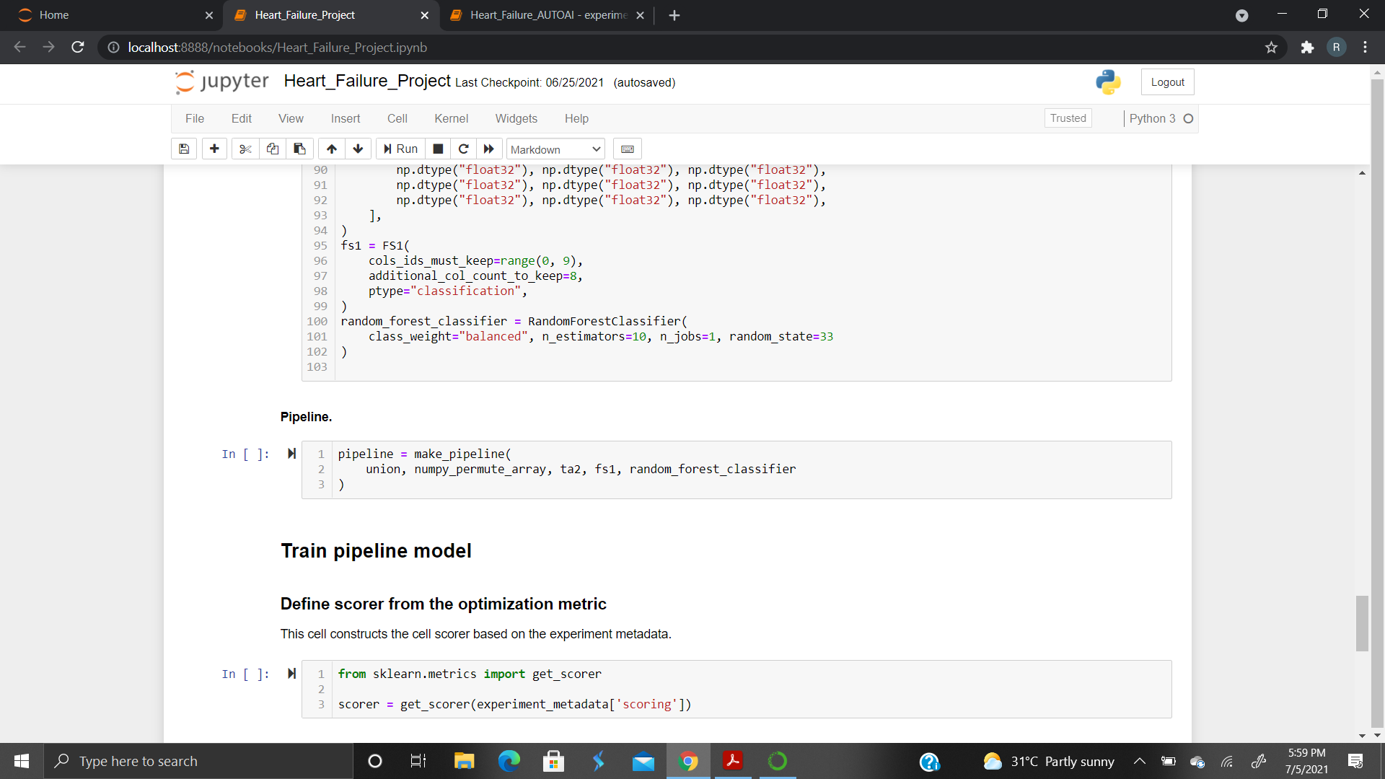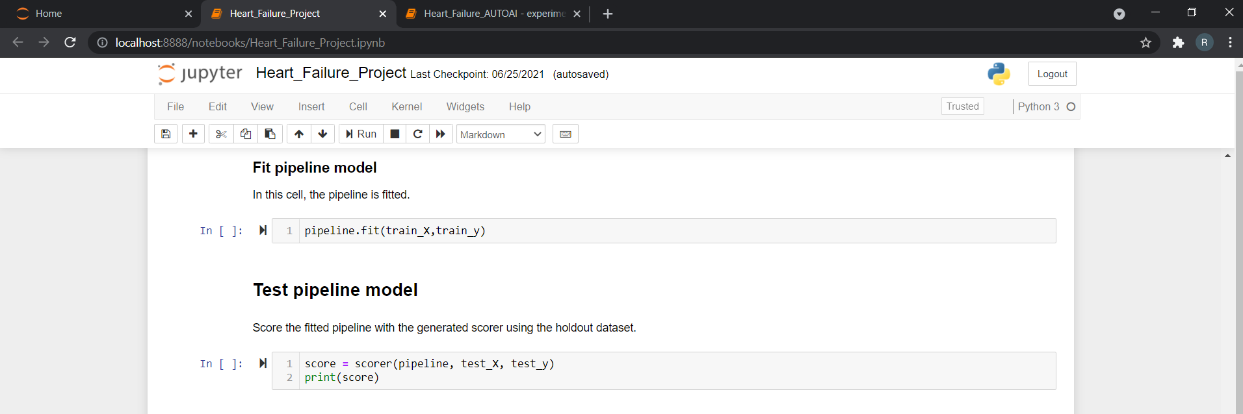

**NODE -RED .json code:**

[{"id":"2a9e9c.fe4df164","type":"tab","label":"Flow 1","disabled":false,"info":""},{"id":"b351bda2.df9dc","type":"ui_form","z":"2a9e9c.fe4df164","name":"","label":"Enter the values:","group":"8925e5c1.b7cd58","order":4,"width":0,"height":0,"options":[{"label":"Avg Heartbeat / Min","value":"h","type":"number","required":true,"rows":null},{"label":"Palpitations / Day","value":"p","type":"number","required":true,"rows":null},{"label":"Cholesterol","value":"c","type":"number","required":true,"rows":null},{"label":"BMI","value":"b","type":"number","required":true,"rows":null},{"label":"Age","value":"a","type":"number","required":true,"rows":null},{"label":"Exercise (min)","value":"e","type":"number","required":true,"rows":null}],"formValue":{"h":"","p":"","c":"","b":"","a":"","e":""},"payload":"","submit":"submit","cancel":"cancel","topic":"topic","topicType":"msg","splitLayout":"","x":110,"y":140,"wires":[["14a5fe7.9bd9602"]]},{"id":"a106b3ac.faada","type":"debug","z":"2a9e9c.fe4df164","name":"","active":false,"tosidebar":true,"console":false,"tostatus":false,"complete":"false","statusVal":"","statusType":"auto","x":630,"y":140,"wires":[]},{"id":"5f8341a1.672b3","type":"ui_dropdown","z":"2a9e9c.fe4df164","name":"","label":"Sex","tooltip":"","place":"Select option","group":"8925e5c1.b7cd58","order":1,"width":0,"height":0,"passthru":true,"multiple":false,"options":[{"label":"Female","value":"F","type":"str"},{"label":"Male","value":"M","type":"str"}],"payload":"","topic":"topic","topicType":"msg","x":100,"y":220,"wires":[["bf6987a4.b83138"]]},{"id":"15375776.e8dce9","type":"ui_dropdown","z":"2a9e9c.fe4df164","name":"","label":"Smoker Last 5 Years?","tooltip":"","place":"Select option","group":"8925e5c1.b7cd58","order":3,"width":0,"height":0,"passthru":true,"multiple":false,"options":[{"label":"Yes","value":"Y","type":"str"},{"label":"No","value":"N","type":"str"}],"payload":"","topic":"topic","topicType":"msg","x":160,"y":340,"wires":[["67e90d23.272ad4"]]},{"id":"39db26e7.a44faa","type":"ui_dropdown","z":"2a9e9c.fe4df164","name":"","label":"Family History?","tooltip":"","place":"Select option","group":"8925e5c1.b7cd58","order":2,"width":0,"height":0,"passthru":true,"multiple":false,"options":[{"label":"Yes","value":"Y","type":"str"},{"label":"No","value":"N","type":"str"}],"payload":"","topic":"topic","topicType":"msg","x":130,"y":280,"wires":[["b9a60e93.d45a4"]]},{"id":"87a7c812.1ad978","type":"debug","z":"2a9e9c.fe4df164","name":"","active":false,"tosidebar":true,"console":false,"tostatus":false,"complete":"false","statusVal":"","statusType":"auto","x":510,"y":220,"wires":[]},{"id":"a921828b.6cc3c","type":"debug","z":"2a9e9c.fe4df164","name":"","active":false,"tosidebar":true,"console":false,"tostatus":false,"complete":"false","statusVal":"","statusType":"auto","x":510,"y":280,"wires":[]},{"id":"3db3d423.6a937c","type":"debug","z":"2a9e9c.fe4df164","name":"","active":false,"tosidebar":true,"console":false,"tostatus":false,"complete":"false","statusVal":"","statusType":"auto","x":550,"y":340,"wires":[]},{"id":"14a5fe7.9bd9602","type":"function","z":"2a9e9c.fe4df164","name":"global variables for form node","func":"global.set(\"heartbeat\",msg.payload.h)\nglobal.set(\"palpitations\",msg.payload.p)\nglobal.set(\"cholesterol\",msg.payload.c)\nglobal.set(\"bmi\",msg.payload.b)\nglobal.set(\"age\",msg.payload.a)\nglobal.set(\"exercise\",msg.payload.e)\nvar apikey = \"e69plhPAwXwqEHbn0o4Oouxz9GESMgrDNhRGHWMRBy93\"\nmsg.headers={\"content-type\":\"application/x-www-form-urlencoded\"}\nmsg.payload={\"grant_type\":\"urn:ibm:params:oauth:grant-type:apikey\",\"apikey\":apikey}\nreturn msg;","outputs":1,"noerr":0,"initialize":"","finalize":"","libs":[],"x":370,"y":140,"wires":[["a106b3ac.faada","ce993b97.fa0a48"]]},{"id":"bf6987a4.b83138","type":"function","z":"2a9e9c.fe4df164","name":"sex","func":"global.set(\"sex\",msg.payload)\nreturn msg;","outputs":1,"noerr":0,"initialize":"","finalize":"","libs":[],"x":320,"y":220,"wires":[["87a7c812.1ad978"]]},{"id":"b9a60e93.d45a4","type":"function","z":"2a9e9c.fe4df164","name":"family","func":"global.set(\"family\",msg.payload)\nreturn msg;","outputs":1,"noerr":0,"initialize":"","finalize":"","libs":[],"x":330,"y":280,"wires":[["a921828b.6cc3c"]]},{"id":"67e90d23.272ad4","type":"function","z":"2a9e9c.fe4df164","name":"smoker","func":"global.set(\"smoker\",msg.payload)\nreturn msg;","outputs":1,"noerr":0,"initialize":"","finalize":"","libs":[],"x":360,"y":340,"wires":[["3db3d423.6a937c"]]},{"id":"ce993b97.fa0a48","type":"http request","z":"2a9e9c.fe4df164","name":"","method":"POST","ret":"obj","paytoqs":"ignore","url":"https://iam.cloud.ibm.com/identity/token","tls":"","persist":false,"proxy":"","authType":"","x":660,"y":80,"wires":[["6549aecc.8c5f6","1edd83c2.9c4c5c"]]},{"id":"6549aecc.8c5f6","type":"debug","z":"2a9e9c.fe4df164","name":"","active":false,"tosidebar":true,"console":false,"tostatus":false,"complete":"false","statusVal":"","statusType":"auto","x":880,"y":140,"wires":[]},{"id":"1edd83c2.9c4c5c","type":"function","z":"2a9e9c.fe4df164","name":"","func":"var heb = global.get(\"heartbeat\")\nvar pal = global.get(\"palpitations\")\nvar cho = global.get(\"cholesterol\")\nvar bm = global.get(\"bmi\")\nvar ag = global.get(\"age\")\nvar sx = global.get(\"sex\")\nvar fm = global.get(\"family\")\nvar sk = global.get(\"smoker\")\nvar ex = global.get(\"exercise\")\nvar token = msg.payload.access_token\nmsg.headers={'Content-Type': 'application/json',\"Authorization\":\"Bearer\"+token,\"Accept\":\"application/json\"}\nmsg.payload={\"input_data\":[{\"fields\":[[\"heartbeat\",\"palpitations\",\"cholesterol\",\"bmi\",\"age\",\"sex\",\"family\",\"smoker\",\"exercise\"]],\"values\":[[heb,pal,cho,bm,ag,sx,fm,sk,ex]]}]}\nreturn msg;","outputs":1,"noerr":0,"initialize":"","finalize":"","libs":[],"x":910,"y":80,"wires":[["52e12483.47a76c"]]},{"id":"52e12483.47a76c","type":"http request","z":"2a9e9c.fe4df164","name":"","method":"POST","ret":"obj","paytoqs":"ignore","url":"https://us-south.ml.cloud.ibm.com/ml/v4/deployments/8dbb3f9e-f766-4c87-8e23-983eaef0b7ca/predictions?version=2021-06-27","tls":"","persist":false,"proxy":"","authType":"","x":1090,"y":80,"wires":[["1f999b42.f90c35","a194bd53.30f52"]]},{"id":"1f999b42.f90c35","type":"debug","z":"2a9e9c.fe4df164","name":"","active":true,"tosidebar":true,"console":false,"tostatus":false,"complete":"false","statusVal":"","statusType":"auto","x":1270,"y":140,"wires":[]},{"id":"a194bd53.30f52","type":"function","z":"2a9e9c.fe4df164","name":"","func":"msg.payload = msg.payload.predictions[0].values[0][0]\nreturn msg;","outputs":1,"noerr":0,"initialize":"","finalize":"","libs":[],"x":1300,"y":80,"wires":[["2c254550.11502a","90b8ff3a.c9c6d"]]},{"id":"2c254550.11502a","type":"debug","z":"2a9e9c.fe4df164","name":"","active":true,"tosidebar":true,"console":false,"tostatus":false,"complete":"payload","targetType":"msg","statusVal":"","statusType":"auto","x":1550,"y":180,"wires":[]},{"id":"90b8ff3a.c9c6d","type":"ui_text","z":"2a9e9c.fe4df164","group":"8925e5c1.b7cd58","order":5,"width":0,"height":0,"name":"","label":"Heart Failure:","format":"{{msg.payload}}","layout":"row-spread","x":1560,"y":80,"wires":[]},{"id":"8925e5c1.b7cd58","type":"ui_group","name":"Form","tab":"b842d019.aaf8b","order":1,"disp":true,"width":"6","collapse":false},{"id":"b842d019.aaf8b","type":"ui_tab","name":"Heart Failure Prediction","icon":"dashboard","disabled":false,"hidden":false}]

1. **UI Output Screenshot:** 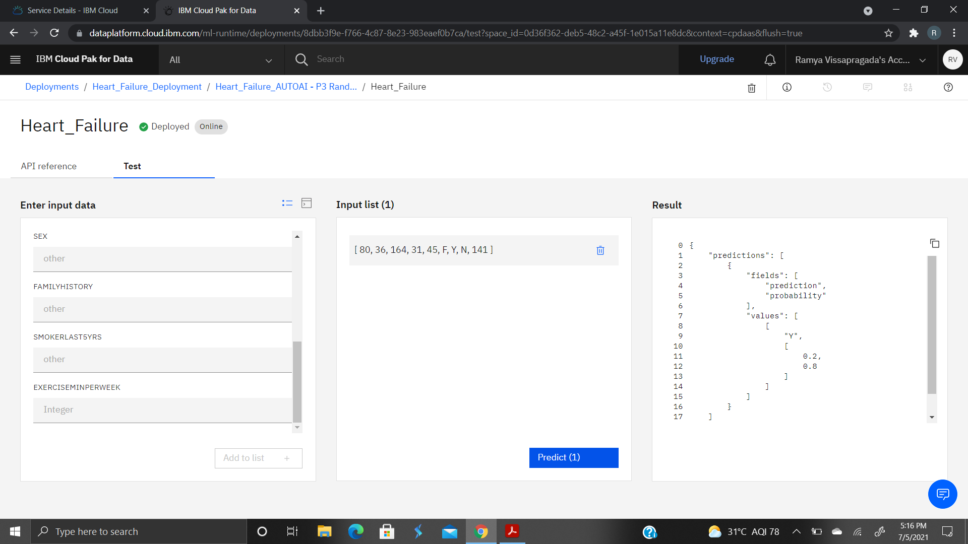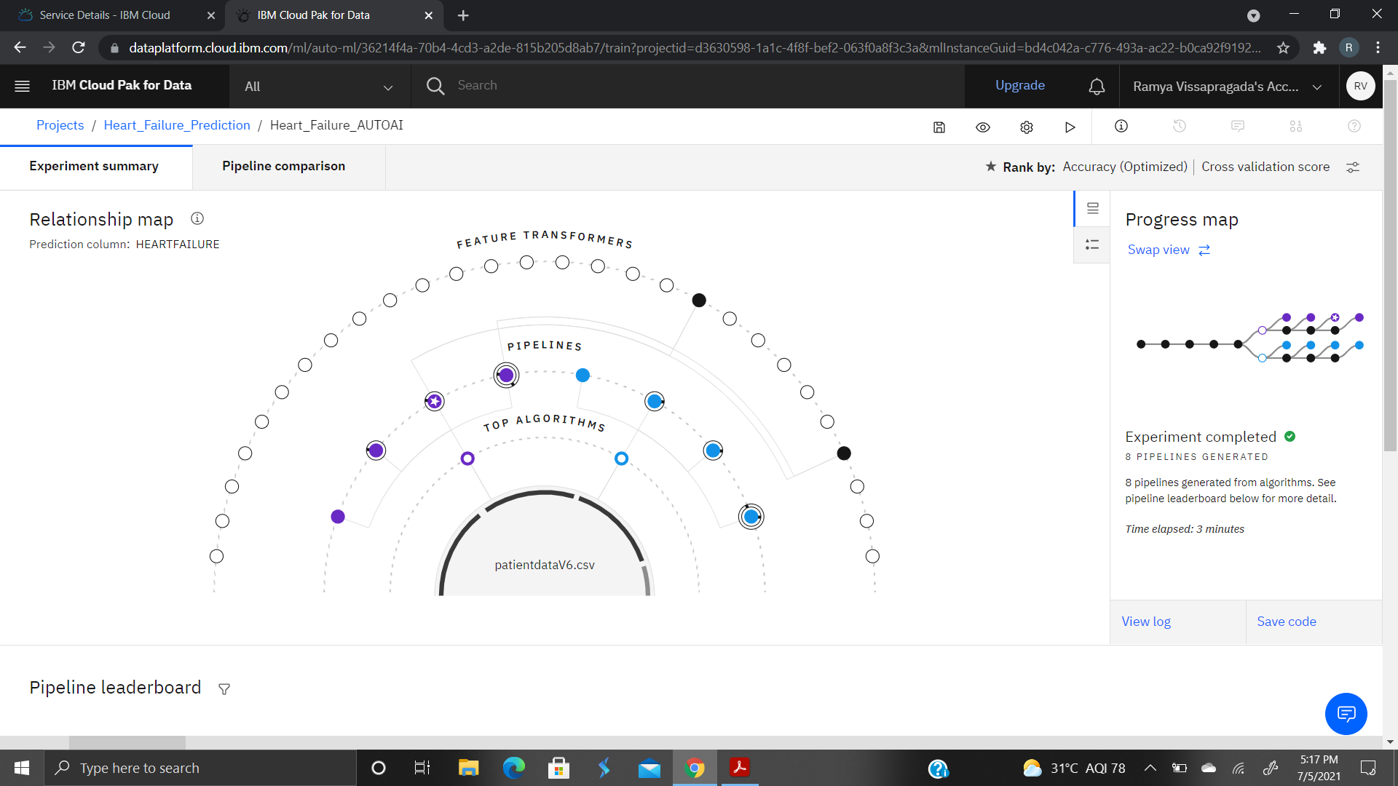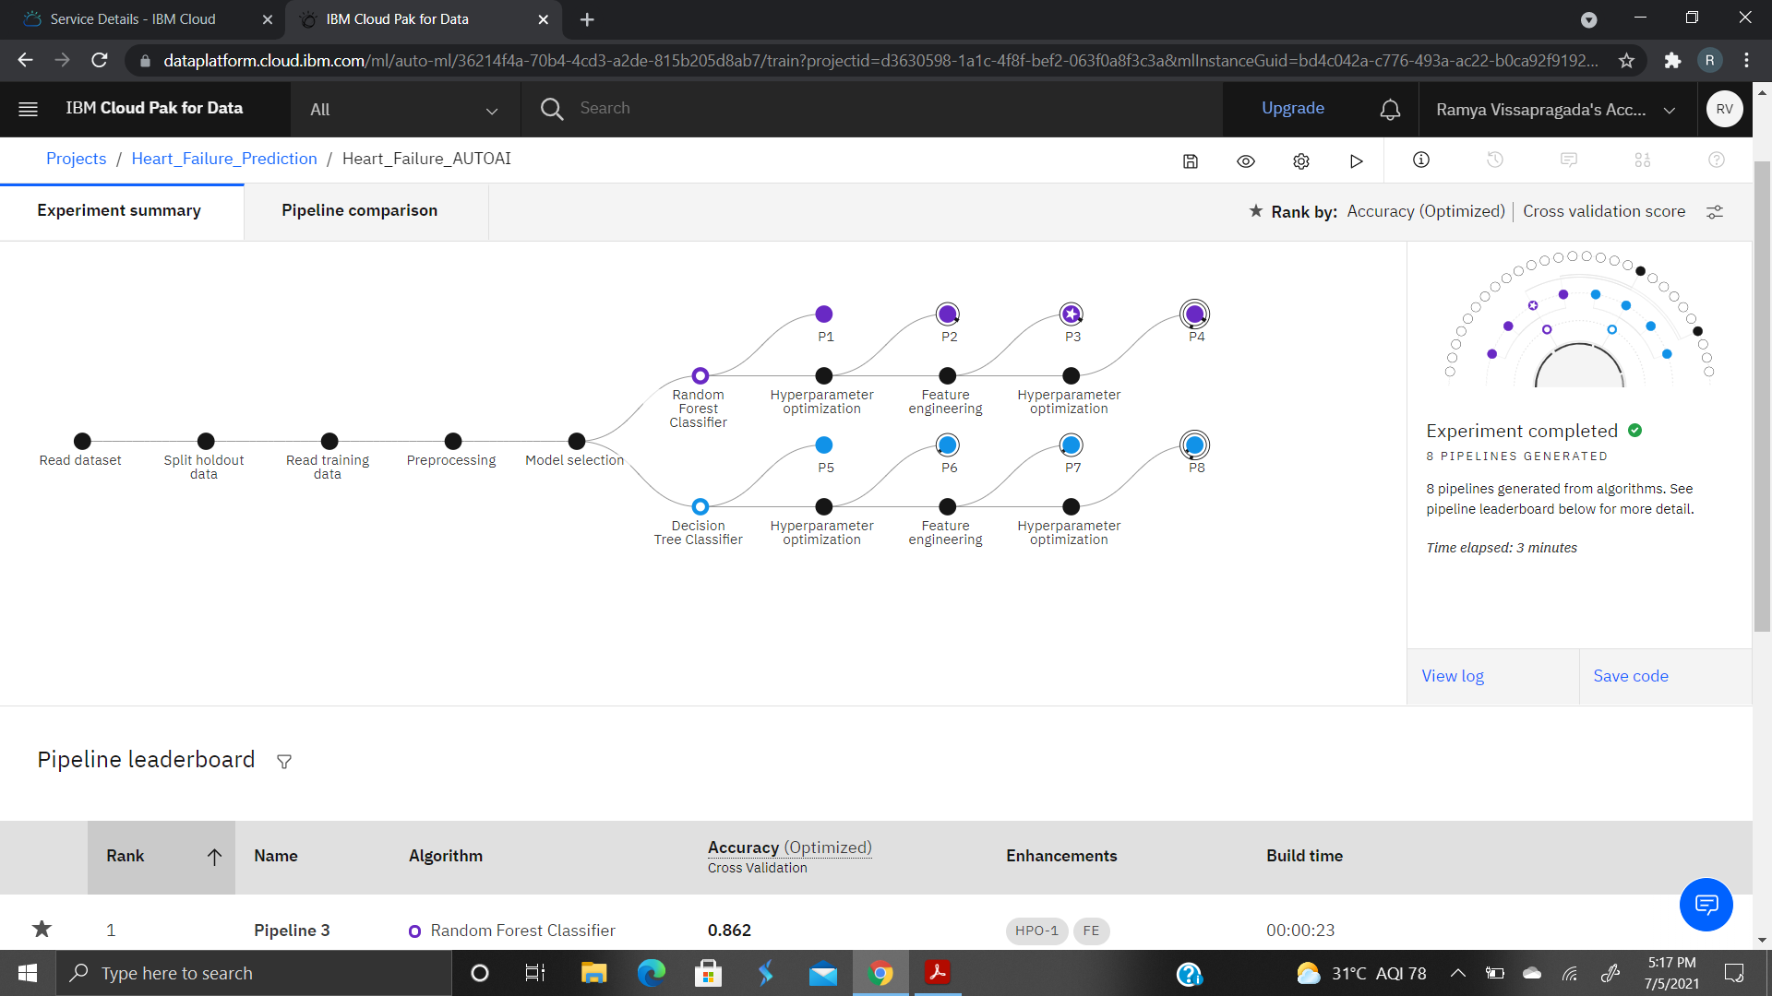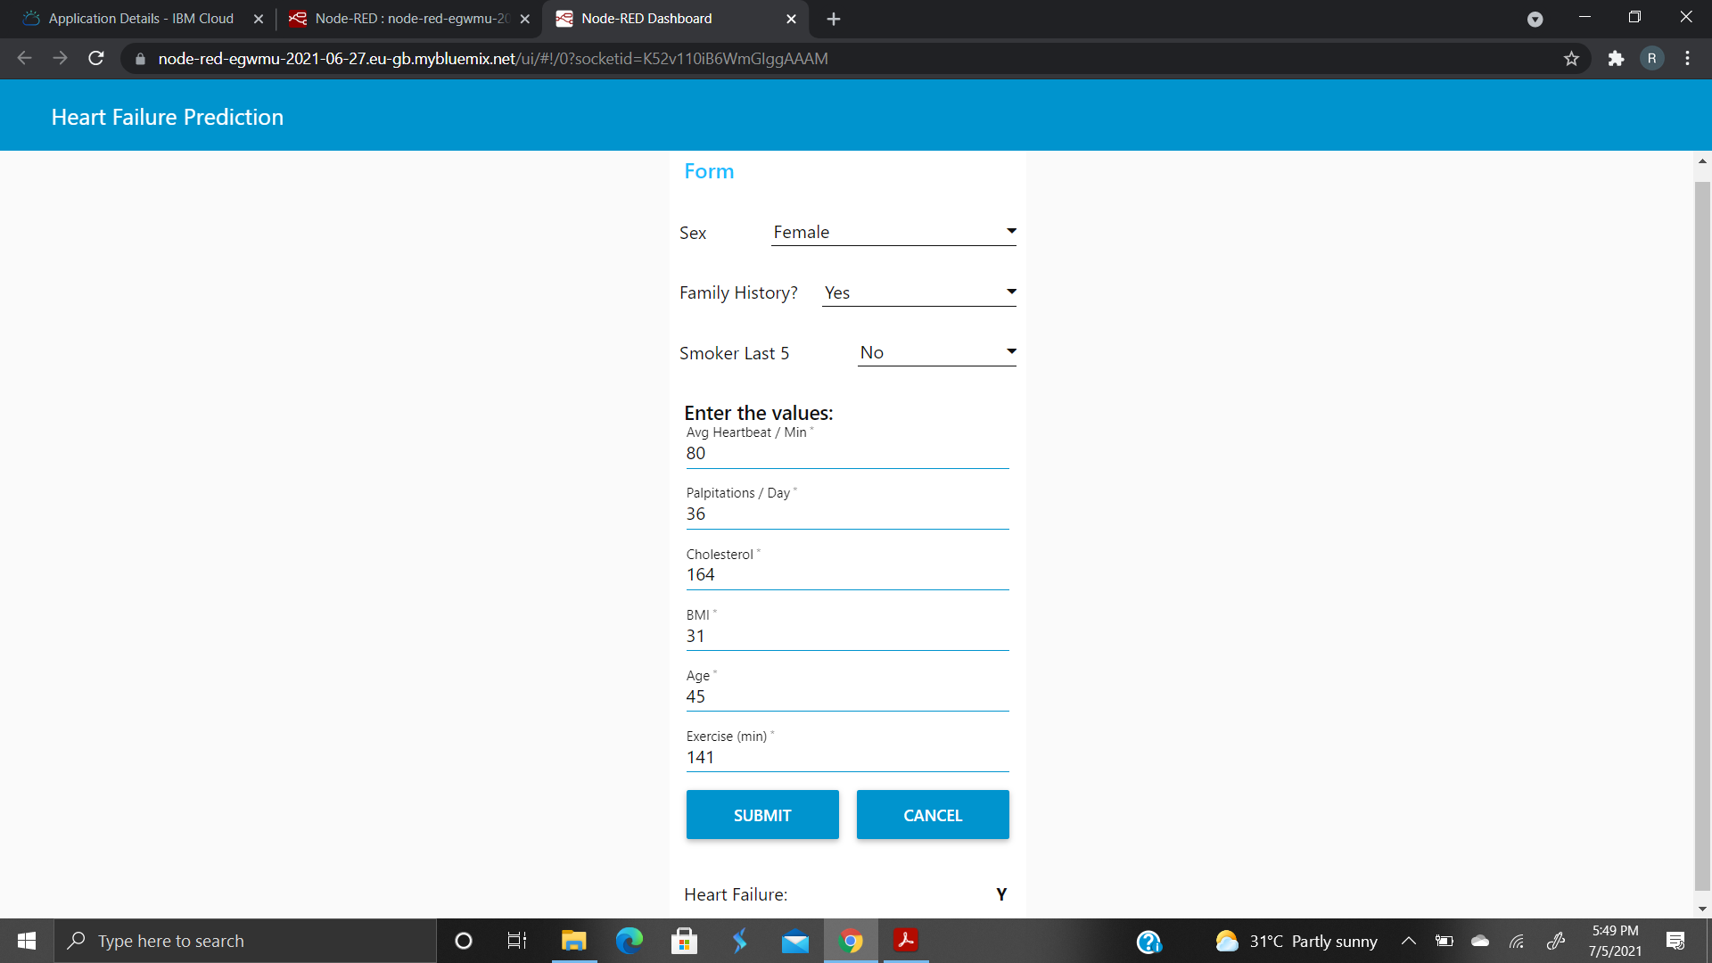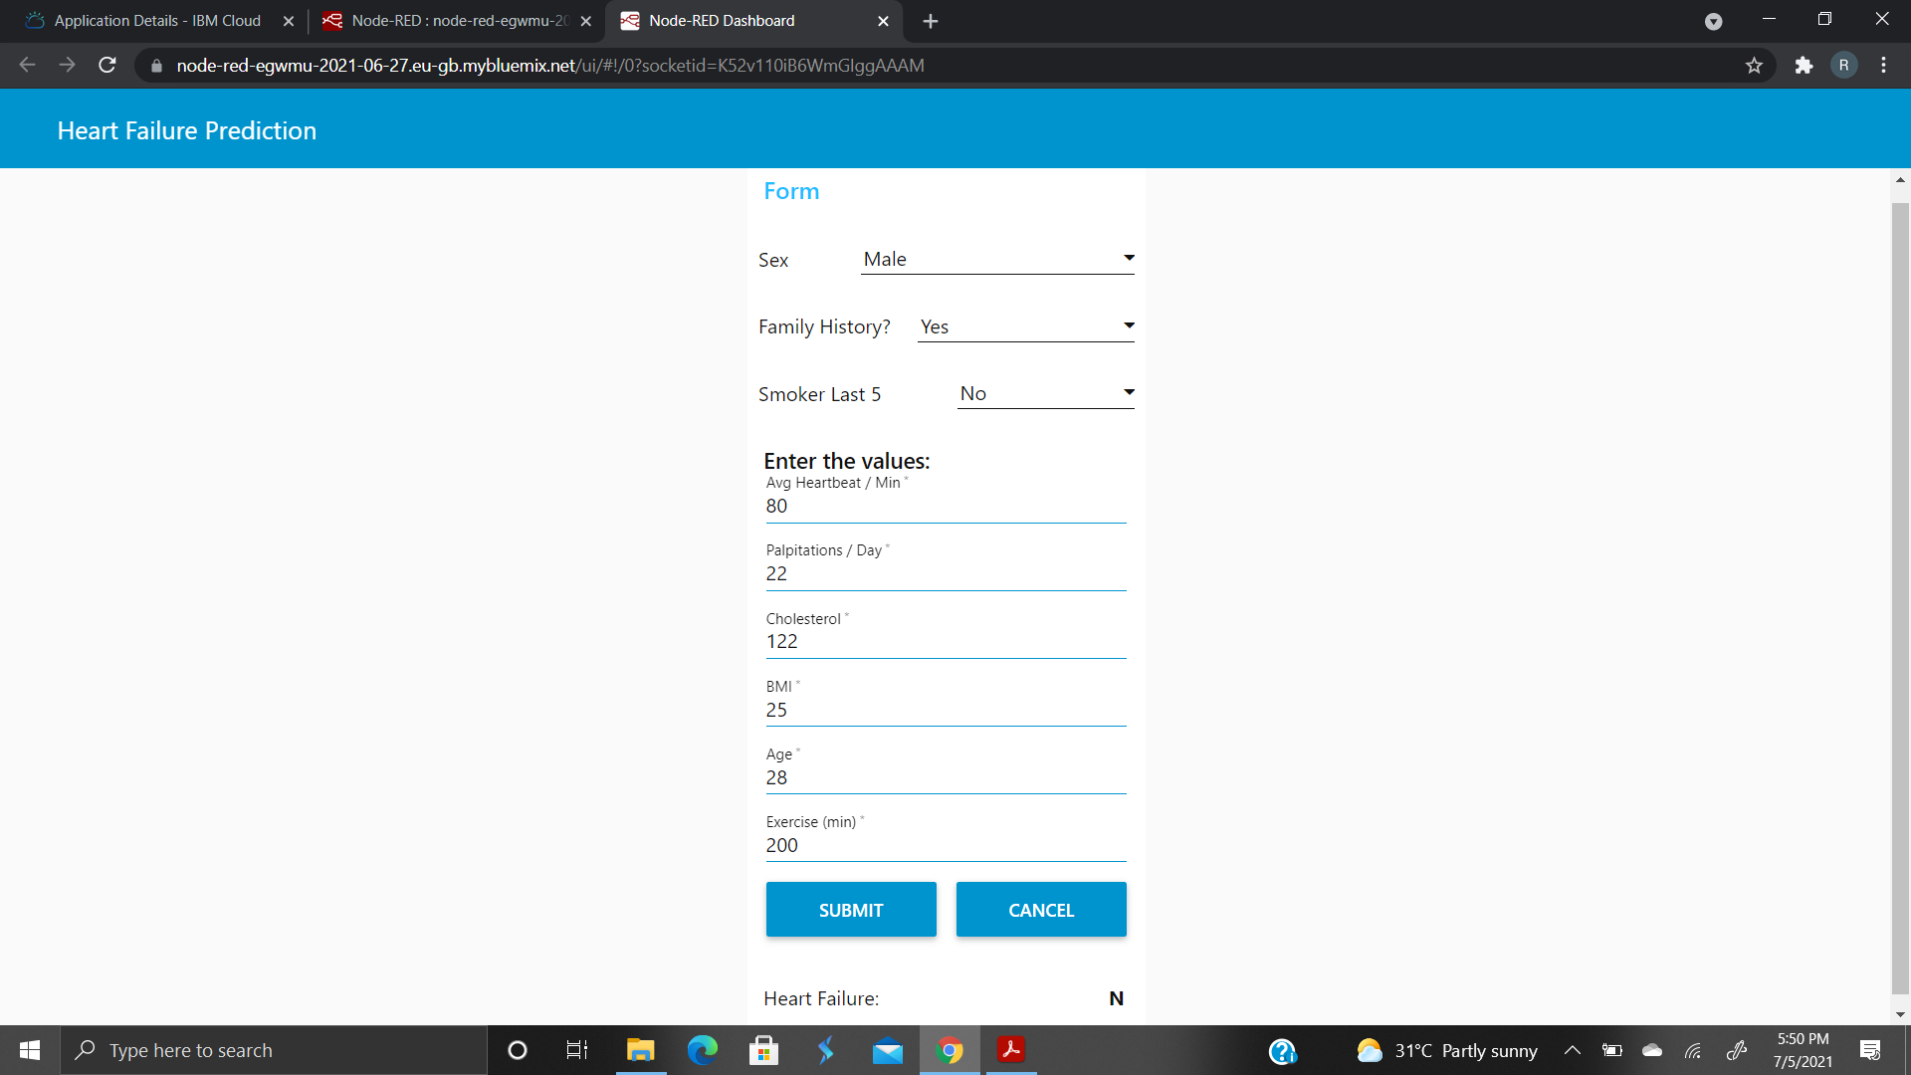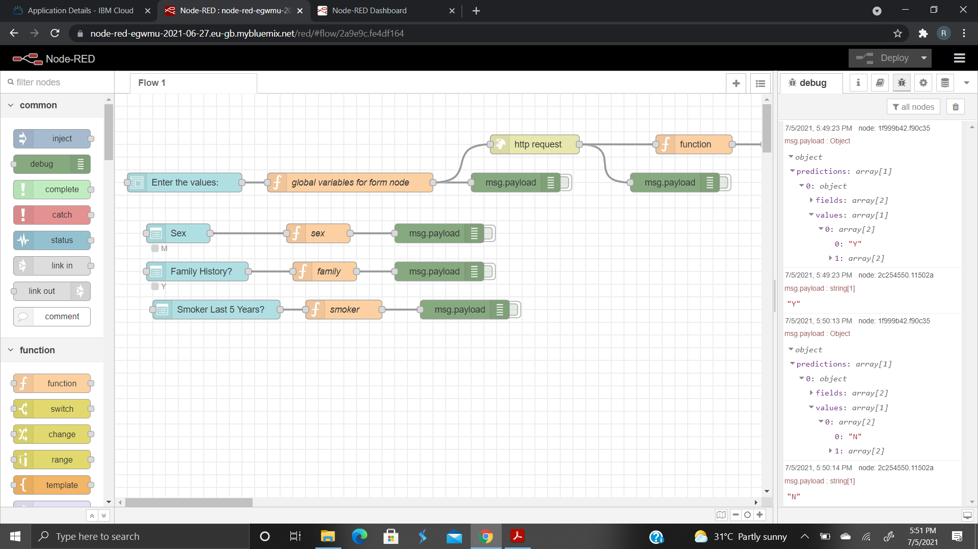

**NAME:** RAMYA RAJESWARI VISSAPRAGADA

**BATCH:** MAY 10th 2021.

